Pedagogical and Technical Solutions to Non-Supervised Summative
Online e-Assessment Challenges

Abstract: The goal of this research is to identify key factors affecting non-supervised summative online e-assessments, and present pedagogical and technical solutions to enhance efficiency and effectiveness of the e-assessments via enhanced recursive and iterative e-assessments lifecycle that detects and prevents e-Cheating.
Keywords: Supervised e-Learning, Online e-Assessments, Statistical Analysis, e-Learning Data, Test Time, Test Results
- Introduction
Influenced by advances in technology, the assessment process has begun to make its way out of the traditional classroom into online environments. Assessment can take place in different learning situations for different pedagogical purposes. There is a diagnostic role for e-assessment in determining students’ prior knowledge of a subject, and another role in grading students. e-assessment can be supervised or non-supervised, formative or summative. In higher education, summative e-assessments can occur in supervised and non-supervised environments. Supervised environments include campus based exams and authorised test centers (Brawner, 2000). non supervised e-assessments are assessments that are conducted online. There exists enormous advantages in adopting summative e-assessments over traditional methods; this includes automated marking, immediate feedback, and on-demand tests, time savings for the instructors, and cost savings for department who traditionally hire grading assistants to aid with the process.

Though e-assessment can provide tutors with feedback for evaluation of modules / courses, a main challenge remains, that is unsupervised e-assessment sessions present a risk of plagiarism. Roger (2006) argues that some faculty are indeed staying away from online e-assessment because of their concerns about e-cheating (Rogers, 2006). Unless assessments are robust, reliable and valid they will be uselss (Burke, 2006). There are concerns about academic dishonesty taking place while administering online e-assessment. Kirillova presents a SWOT analysis of different distance education approaches highlighting that one of the main threats of online teaching is the increase risk of cheating (2000). Over half of the Georgia Southern University, faculty are using online e-assessment and that there is some concern about online cheating, but the majority of them are not proactively implementing measures to prevent it (Rogers, 2006).

e-Cheating tips are many, and include students accessing other websites, communicating with others via instant messaging tools and email during the exam, seeding test computers with answers, and bringing in non-exam disks containing solutions to the exam (Baker, 2003). One solution was to install the commercial security program NetSupport Classroom Software into labs. Included among the features of this type of software the ability to view each student’s computer screen at anytime on an instructor terminal and a lock feature preventing accessing to the other applications other than the exam. However, that kind of solution is non-applicable in complete distance learning programs as students conduct e-assessments from their homes.

Additional measures used to prevent e-cheating can be accomplished within a controlled environment by having students attend a testing center as was done on a wide scale basis in the Texas university system (Young, 2001). However, testing centers for online classes can be problematic because it deters some students who need the class from taking it because they are not geographically located near the testing site (Carlson, 2000). The solution is to use flexibility based on individual needs, and the tracking of IP addresses and timed exams, thus isolating a student to the same computer for each exam, regardless of proximity to the instructor. This solution utilized the concept of tracking student’s methods of attending the exam unfortunately without completing the image by tracking students’ behaviour during the exam and analyzing student's grades. With the desire to rely heavily on e-Learning in ranking students, the idea of studying students’ online behavior and further analyze it has turned into a priority (Rovai, 2000).

The use of 'test time' as a variable as well as 'test results' is a sensible variable to include in analyzing students behaviour. The attempt to find a relation between test time and test results presented the problem of this research: many students score high marks within time periods that are not enough to read the questions, from instructors point of view. That implies different things, including the need to update questions repository, changing the automated assessments generation mechanism of action, or the possibility of e-cheating. In order to identify which path to take to face this challenge, different perspectives shall be handled effectively. Perspectives related to assessments include:
- Assessment Questions Diversity: Assessments shall include different types of questions that test different students knowledge and educational characteristics.
- Assessment Difficulty: Assessments shall differ in faculty, with diverse questions difficulty levels, to be able to analyze each assessment, and identify strength and weakness points for each assessment.
- Assessment Response Time: Recording assessment solving time enabled us to identify the problem, and opened the door to further study students' behaviour.
Another perspective, that is related to students' behaviour implies the need to keep an eye on students through conducting non-formal interviews and tracking their behaviour during assessments. Tracking students' behaviour through web-based systems is quiet a challenge. However, test time can be used as an indicator of the behaviour.

The goal of this research is to identify key factors affecting non-supervised summative online e-assessments, and present pedagogical and technical solutions to enhance efficiency and effectiveness of the e-assessments via enhanced recursive and iterative e-assessments lifecycle that detects and prevents e-Cheating. Thinking about e-assessments in terms of lifecycle, that yields us to the effective e-assessment. e-Assessment lifecycle shall consists of five phases, as presented in figure 5:
- Authoring: Assessments shall test different intellectual, knowledge, and other students' skills. Thus, assessments shall consist of different types of questions, with varying questions difficulty levels, and so different assessments difficulty levels.
- Analyzing: Analyzing e-assessments from different parameters, like students' scores and test time allows instructors to identify points of strengths and weaknesses within each assessment. Different decisions regarding each assessment can be made based on instructors thoughts about expected test time, and test scores, and to what extent students satisfy those expectations. e-Cheating cases appears clearly here, as will be discussed in later sections.
- Enhancing: Based on analysis results, instructors shall strengthen weaknesses and focus on strengths. For example, to reach a balanced assessment, instructors might need to take off some of the easy questions that exists; because all students answer those questions correctly. Same can be applied with hard questions that rarely answered correctly and might need to be removed for sake of easier questions.
- Mining: Finding hidden relations between students behaviour and students scores can be achieved via data mining techniques that might be applicable after running the assessments for some time, and conducting an intensive amount of data. Mining can include historical data that can be used to fine tune assessments.
- Enhancing: Back to the enhancing phase, where mining decisions help avoiding weaknesses and maintaining strengths.
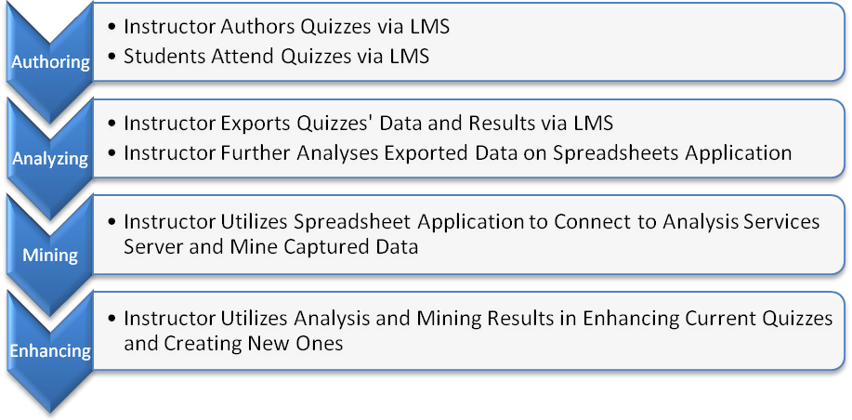
Figure 5: Enhanced e-Assessments Life cycle
This paper goes as follows:
- Methodology
Comparison between supervised and non-supervised e-assessments is an indication to check the efficiency and effectiveness of non-supervised e-assessments when compared to supervised ones. Classifying students based on test time is a factor in studying students behaviour. Thus, conducting the same e-assessments in both supervised and non-supervised environments, separating collection of students into three groups: group that attended the non-supervised assessment only, other that attended the supervised assessment only, and a third that attended both the supervised and non-supervised assessment, and further analyzing the results might help with this problem identification, and in presenting solution.

One of the courses taught in Faculty of Computers and Information Sciences in Mansoura University of Egypt is “Information Systems Analysis and Design,” a course which utilizes different features of learning and e-learning activities. One of the activities that have been utilized since 2008 is online assessment. Though online assessment is not the only criteria to qualify students, it is still an important feature because of the many advantages of enhancing learning experience, automated assessments marking, assessments and assessments’ items analysis, and students’ profiles features. However, one of the problems that prevent us from taking full advantage of online assessments is when students leak the assessments to others—in other words, cheat. Students search online for the questions and answers, and unfortunately, they can generally find them easily enough. Screenshots of questions, answers, final grade of those answers, and attendance date of the exams often come up in search results. Of course, it is students’ choice to seek and use this information, or not. Online assessments are not conducted in a secure and supervised environment. The argument is that distance learning is based on the ability to provide different types of activities for remote students that they can complete in their own time and environment. Tracking, analyzing, and mining online assessments data and results of this course for the last three years reveals important facts about unsupervised learning environments, specifically unsupervised online assessments. During assessment results’ analysis, some surprising facts became clear.

This paper goes as follows: Section two presents statistical analysis of non-supervised online assessments conducted in earlier academic years and identifies the research questions and problem domain analysis, section three presents the comparison study between supervised and non-supervised online assessments conducted in the academic year 2009-10, further analysis of those statistics, and comments on results. Section four discusses some cheating tips witnessed through monitoring students. Section five presents a proposed pedagogical and technical solution and Section six concludes the paper. Paper ends with references.
- Non-supervised Online Assessments’ Problem Domain Analysis
Table 1 presents statistics about three non-supervised online assessments conducted in the academic years 2007-08, and 2008-09. Utilized questions in those assessments are very well prepared; some of them are available via the resources available from the book author(s), and the rest are prepared internally. Question types and severity levels are available in the table and aims mainly to assess student's ability to remember Information Systems Analysis and Design facts, definitions, and the capability to deal with different UML diagrams and components of those diagrams that are necessary to present systems models. Appendix A includes samples of the different questions of each assessment. Number of students with high grades in an almost “not enough time to read the questions” is high. There were a noticeable number of students who finished the assessment in less than 10 minutes and scored higher than 30 out of 50. Luckily, the students do not know that the system records their starting time and ending time, and thus total time, or they would have at least spent more time on screen just pretending to be read and think through each question. In order to take a closer look on quizzes’ data, students were categorized into six groups based on the time consumed within each quiz. Table 2 presents the different groups in this paper. Participation in those assessments was on voluntary basis and this justifies the low participation level in some cases. However, this doesn’t give an excuse for careless students who didn’t participate.

Table 1: Statistics for 3 Earlier Unsupervised Online Assessments
 | 1st 2008 | 2nd 2008 | 1st 2009
Enrolled Students | 223 | 223 | 184
Online Students | 183 | 162 | 91
Total Marks | 50 | 50 | 50
Time Average | 19.8 min. | 18.7 min. | 19.8 min.
Marks Average | 34 | 39 | 30.5
Total No. of Questions | 50 | 50 | 50
Types of Questions | T/F | T/F | T/F
Overall Difficulty Level | Medium | Medium | Medium
T/F Questions | 50 | 50 | 50
Easy T/F Questions | 5 | 4 | 5
Medium T/F Questions | 35 | 44 | 35
Hard T/F Questions | 10 | 2 | 10
Group 0 | 4 | 9 | 0
Group 1 | 52 | 46 | 32
Group 2 | 63 | 52 | 22
Group 3 | 28 | 29 | 20
Group 4 | 11 | 11 | 4
Group 5 | 14 | 5 | 7
Group 6 | 11 | 10 | 6
Table 2: Different Students Groups
Group 0 | Students started but did not complete the assessment.
Group 1 | Students conducted the assessment in duration between 0 and 10 min.
Group 2 | Students conducted the assessment in duration between 10 and 20 min.
Group 3 | Students conducted the assessment in duration between 20 and 30 min.
Group 4 | Students conducted the assessment in duration between 30 and 40 min.
Group 5 | Students conducted the assessment in duration between 40 and 50 min.
Group 6 | Students conducted the assessment in duration between 50 and 60 min.

Gipps (1994) defines different aspects of assessments. Successful assessments refer to assessments that can effectively and efficiently differentiate different learning skills gained and acquired by different students. Successful assessments’ components are: consumed time, scored marks, and questions answered. In the attempt to identify the relations between those components; especially between consumed time and scored marks, some graphs that summarize analysis of the assessments are presented. Figure 1 shows the percentage of students with variant assessment completion times for the three assessments respectively. Figure 2 shows the time distribution of students per each quiz. Figure 3 shows marks distribution for students per each quiz. Figure 4 highlights the relevance between times consumed solving the assessments and scored marks. There are some alarming remarks that took place in the three unsupervised assessments:
- Around 25% of students belong to Group 1. Group 1 students’ finish assessment within less than 10 minutes; which is believed not to be enough time just for reading the assessment, not for thinking about it and solving it.
- There are no clear relations between consumed times solving the assessments and scored marks.
- In 1st Quiz 2008 results, students spent longer time solving the quiz and scored lower marks than students conducted the 2nd Quiz 2008 though both quizzes consist of the same number of questions and same type of questions.
- In 1st Quiz 2009, students spent less time solving the quiz and scored much less marks than other students.
- In the three quizzes, Groups 4, 5, and 6 percentages are low, and their marks are not the highest. What would be those students’ response if the amount of time allowed for the assessment shortens? Would they join Group 3 with the same scored marks?

Besides, there are some questions that need answer via experiencing different alternatives. Questions include:
- What is the most type of questions that students take longer time answering from the True/False, Matching, and Multiple Choice Questions?
- Is it better to mix the three types of questions together within the assessment?
- What is the relation between genders, consumed time, and scored marks?
- What are other data that can be extracted from further analyzing and mining assessments’ results and data?
- Can non-supervised environment assessments be reliable enough in grading students?
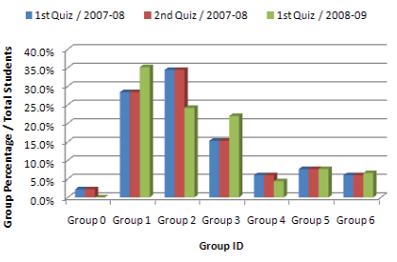  Figure 1: Group Percentages Per Assessment | 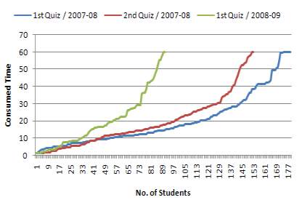  Figure 2: Time Distribution Per Assessment
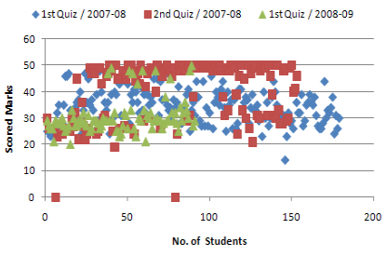  Figure 3: Marks Distribution Per Assessment | 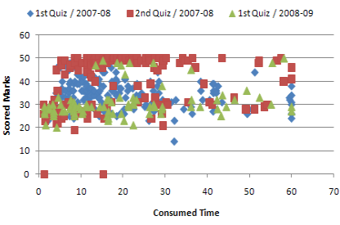  Figure 4: Time and Marks Relevance Per Assessment

- Comparison Study between Non-supervised and Supervised Online Assessments
Six different assessments were conducted in both supervised and non-supervised environments to highlight differences between both environments and to test to what extent there are leaks in non-supervised environment assessments. Table 3 presents data about those assessments. Different types of questions were presented in those assessments hopefully to identify the most efficient types of questions to be used. Figure 5 presents an enhanced assessments’ authoring model via utilizing available spreadsheets applications and data mining tools and techniques. This model is applied in this paper to enhance the assessments life cycle. Table 4 presents further statistics for each quiz based on Groups’ percentages and compares between each group in both the supervised and non-supervised environments. Figure 6 presents a representation of the data presented in table 4.

Table 3: Statistics about the Six conducted assessments in 2009-10
 | 1st Quiz | 2nd Quiz | 3rd Quiz | 4th Quiz | 5th Quiz | 6th Quiz
Quiz Title | Quiz 1 | Quiz 2 | Quiz 3 | Quiz 4 | Quiz 5 | Quiz 6
Total Marks | 50 | 50 | 25 | 50 | 50 | 50
Total No. of Questions | 50 | 50 | 20 | 50 | 50 | 50
Types of Questions | T/F | MCQ | Match | Mix | Mix | Mix
Overall Difficulty Level | Med. | Med. | Med. | Med. | Med. | Med.
T/F Questions | 50 | 0 | 0 | 20 | 20 | 20
Easy T/F Questions | 5 | 0 | 0 | 2 | 2 | 3
Medium T/F Questions | 35 | 0 | 0 | 14 | 17 | 17
Hard T/F Questions | 10 | 0 | 0 | 4 | 1 | 0
Multi Choice Questions | 0 | 50 | 0 | 10 | 10 | 10
Easy MCQs | 0 | 3 | 0 | 0 | 0 | 1
Medium MCQs | 0 | 39 | 0 | 8 | 9 | 8
Hard MCQs | 0 | 8 | 0 | 2 | 1 | 1
Match Questions | 0 | 0 | 20 | 20 | 20 | 20

Table 4: Detailed Quizzes' Statistics
 | 1st Quiz |  | 2nd Quiz |  | 3rd Quiz |  | 4th Quiz |  | 5th Quiz |  | 6th Quiz
 | Online | Lab | Online | Lab | Online | Lab | Online | Lab | Online | Lab | Online | Lab
Total Students | 212 | 212 | 212 | 212 | 212 | 212 | 212 | 212 | 212 | 212 | 212 | 212
Enrolled Students | 167 | 46 | 170 | 45 | 166 | 50 | 160 | 69 | 155 | 66 | 153 | 65
Time Average | 24.8 | 16.8 | 26.4 | 21.4 | 7.8 | 3.6 | 22 | 15 | 17 | 15 | 15.4 | 12.7
Marks Average | 39.5 | 29.9 | 39 | 26 | 22 | 15.7 | 35 | 26 | 43.6 | 30 | 42.8 | 21.8
Group 0 | 29 | 0 | 21 | 0 | 5 | 2 | 14 | 0 | 14 | 0 | 13 | 0
Group 1 | 23 | 10 | 22 | 2 | 130 | 38 | 36 | 21 | 37 | 20 | 44 | 29
Group 2 | 40 | 27 | 33 | 20 | 23 | 10 | 41 | 27 | 63 | 32 | 66 | 24
Group 3 | 34 | 5 | 37 | 18 | 7 | 0 | 37 | 17 | 25 | 10 | 17 | 10
Group 4 | 13 | 1 | 26 | 4 | 1 | 0 | 13 | 4 | 7 | 3 | 8 | 1
Group 5 | 14 | 2 | 20 | 1 | 0 | 0 | 7 | 0 | 5 | 1 | 3 | 1
Group 6 | 14 | 1 | 11 | 0 | 0 | 0 | 12 | 0 | 4 | 0 | 2 | 0

Table 5: Further Statistical Analysis based on Grous' Responses
 | Quiz 1 |  |  |  |  |  | 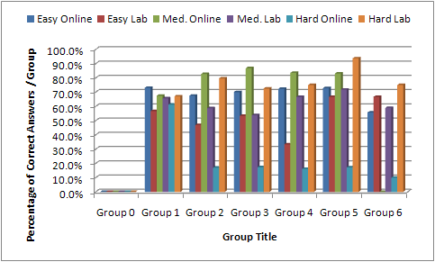  Figure 6: Percentage of Correct Answers for Each Group Based on Questions Difficulty
 | T/F Qs
 | Easy  Online | Easy Lab | Med. Online | Med. Lab | Hard Online | Hard Lab
Group 0 | 0 | 0 | 0 | 0 | 0 | 0
Group 1 | 84/115 | 17/30 | 543/805 | 564/858 | 141/230 | 118/176
Group 2 | 135/200 | 38/81 | 1159/1400 | 618/1053 | 68/400 | 172/216
Group 3 | 119/170 | 8/15 | 1033/1190 | 105/195 | 59/340 | 29/40
Group 4 | 47/65 | 1/3 | 380/455 | 26/39 | 21/130 | 6/8
Group 5 | 51/70 | 4/6 | 407/490 | 56/78 | 24/140 | 15/16
Group 6 | 39/70 | 2/3 | 322/490 | 23/39 | 14/140 | 6/8

In this comparison study, students were divided randomly into three groups based on their Student IDs: Group A, Group B, and Group C. Group A include students that are asked to attend the assessment in lab (supervised environment). Group B are students asked to attend the assessments in non-supervised environment. Group C are students asked to attend the assessments in both supervised and non-supervised environments. Group C are voluntary basis, and they represent intersection between Group A and Group B, and their presence justifies the sum of lab and online students quizzes exceeds the total enrolled students. Presented statistics are an example of data that is made available via utilizing spreadsheets applications. This data can be used in identifying what types of questions each group failed in answering and then modifying upcoming assessments. Figure 6 presents a graph that turns statistics presented in table 5 into meaningful information. This figure summarizes the percentages of correct answers from each group in Quiz 1 categorized in the three questions’ difficulty levels: hard, medium, and easy. Such figures highlight some useful information about students’ performance within quizzes, and can’t be acquired easily via current LMSs. It is clear from the figure that students’ percentage of answering hard questions in unsupervised environment is much less than other types of questions. This might indicate that instructors shall make non-supervised assessments include harder types of questions than supervised ones for sake of testing the real students’ achievements.

Figure 7 presents comparison between Group’s percentage per total enrolled students for supervised and non-supervised Quiz 1. Figure 8 presents time consumption comparison between supervised and non-supervised Quiz 1 instance. Figure 9 highlights marks’ comparison between supervised and non-supervised instances of quiz 1. Figures 10 to 24 present the three comparisons between supervised and non-supervised environments for the rest five quizzes respectively. By studying the comparisons between both environments and when considering the different types of questions included in the six quizzes, it becomes almost clear that:
- Matching Questions is the least type of questions that differentiates between different students’ categories when compared to True/False, and MCQs. In quiz 3, students’ distribution over different groups is different than distribution in quizzes 1, and 2. Matching questions alone weren’t efficient enough in classifying students as the other two types of questions.
- Students spend longer times in non-supervised environments solving the assessments.
- Students score higher marks in non-supervised environments than in supervised environments.
- Group 4, 5, and 6 almost disappears in supervised environments. That indicates that students take less time solving the assessments in supervised environments when compared to non-supervised environments. Though this means that there is a leak in assessments’ predetermined needed time to solve the quiz, it also indicates that students take longer time in non-supervised environments trying to reach the correct answers in a way or another via means that are not accessible in supervised environments.
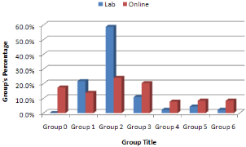  Figure 7: Quiz 1 Groups’ Percentage Comparison | 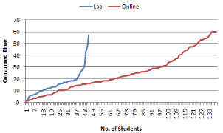  Figure 8: Quiz 1 Time Consumption Comparison | 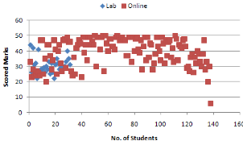  Figure 9: Quiz 1 Scored Marks Comparison
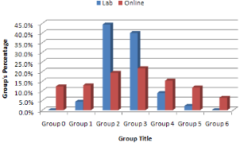  Figure 10: Quiz 2 Group's Percentage Comparison | 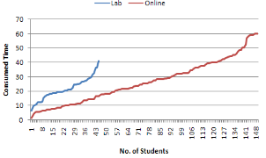  Figure 11: Quiz 2 Time Consumption Comparison | 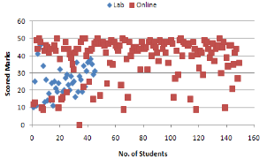  Figure 12: Quiz 2 Scored Marks Comparison
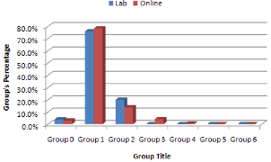  Figure 13: Quiz 3 Group's Percentage Comparison | 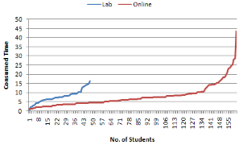  Figure 14: Quiz 3 Time Consumption Comparison | 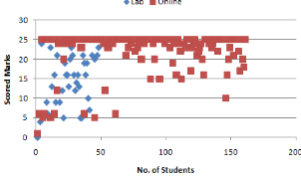  Figure 15: Quiz 3 Scored Marks Comparison
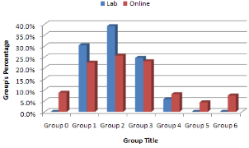  Figure 16: Quiz 4 Group's Percentage Comparison | 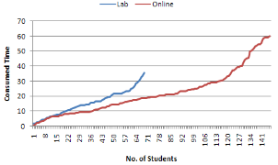  Figure 17: Quiz 4 Time Consumption Comparison | 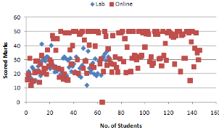  Figure 18: Quiz 4 Scored Marks Comparison
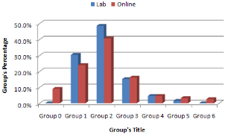  Figure 19: Quiz 5 Group's Percentage Comparison | 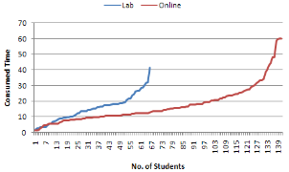  Figure 20: Quiz 5 Time Consumption Comparison | 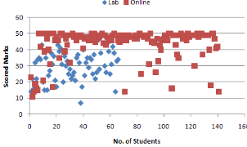  Figure 21: Quiz 5 Scored Marks Comparison
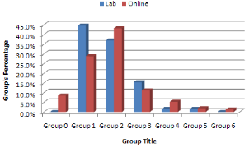  Figure 22: Quiz 6 Group's Percentage Comparison | 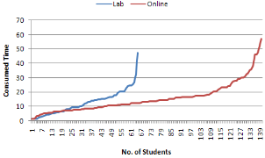  Figure 23: Quiz 6 Time Consumption Comparison | 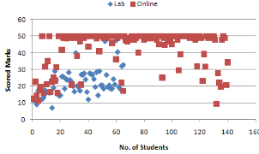  Figure 24: Quiz 6 Scored Marks Comparison

Another form of further assessments’ data and results analysis that is currently not available via LMSs tools and made easier via spreadsheets applications is the capability to distribute students of each group based on their consumed time solving the assessment, and scored marks. Table 5 presents data about the distribution of different students groups based on the relation between consumed times and scored marks. Figure 25 introduces a representational chart of this data. It is noticeable that students’ distribution over groups in supervised environments makes more sense when compared to students’ distribution in non-supervised environment. In lab assessment, groups 1, 2, and 3 mostly scored marks > 20 and <= 30 and groups 4, 6 scored marks >30 and <= 40, and that complies with the belief that statistics recorded about non-supervised environments show leaks in some areas. When compared with groups distribution of students in non-supervised environments, we find students of groups 1, 2, 3, 4, and 5 mostly scored marks > 40 and <=50, and this means in this assessment there was a leak somewhere that lead to the assessment failure to differentiate between different students. This leak of course is not in the assessment itself or the questions because when the same assessment was applied in a supervised environment, it yielded different distribution.

One of the considered determining factors to identify to what extent non-supervised environments can be relied on is the comparison between individuals’ performance in both supervised and non-supervised environments. Some students were invited personally to the conduct the assessments’ twice. Some of them attended the assessment in the supervised environment first, and then they attended it in the non-supervised environment and the others vice versa. Students’ were not told that they will conduct the same assessments twice in both cases. Comparative results are quiet impressive and gives real indication of the students’ performance in non-supervised environments. Figures 26 to 31 compare between students’ consumed time and scored marks in both supervised and non-supervised environments. It is clear from the figures that the same student spent longer time solving the assessment in non-supervised environment, and scored higher marks than s/he scored in the non-supervised environments. The difference in consumed time between both environments is not much irritating as the difference between marks.
Table 6: Students' Distribution Comparison within Each Group Per Scored Marks for Quiz 1
 | <= 10 |  | > 10 & <= 20 |  | > 20 & <= 30 |  | > 30 & <= 40 |  | > 40 & <= 50 |  | Total
 | Online | Lab | Online | Lab | Online | Lab | Online | Lab | Online | Lab |  | Online | Lab
Group 0 | 0.0% | 0.0% | 0.0% | 0.0% | 0.0% | 0.0% | 0.0% | 0.0% | 0.0% | 0.0% |  | 0.0% | 0.0%
Group 1 | 0.0% | 0.0% | 4.3% | 0.0% | 43.5% | 90.0% | 21.7% | 10.0% | 30.4% | 0.0% |  | 100.0% | 100.0%
Group 2 | 0.0% | 0.0% | 0.0% | 0.0% | 20.0% | 55.6% | 12.5% | 33.3% | 67.5% | 11.1% |  | 100.0% | 100.0%
Group 3 | 0.0% | 0.0% | 0.0% | 0.0% | 5.9% | 100.0% | 26.5% | 0.0% | 67.6% | 0.0% |  | 100.0% | 100.0%
Group 4 | 0.0% | 0.0% | 0.0% | 0.0% | 0.0% | 0.0% | 46.2% | 100.0% | 53.8% | 0.0% |  | 100.0% | 100.0%
Group 5 | 0.0% | 0.0% | 0.0% | 0.0% | 21.4% | 0.0% | 21.4% | 0.0% | 57.1% | 100.0% |  | 100.0% | 100.0%
Group 6 | 7.1% | 0.0% | 7.1% | 0.0% | 28.6% | 0.0% | 50.0% | 100.0% | 7.1% | 0.0% |  | 100.0% | 100.0%
Total | 7.1% | 0.0% | 11.5% | 0.0% | 119.4% | 245.6% | 178.3% | 243.3% | 283.7% | 111.1%
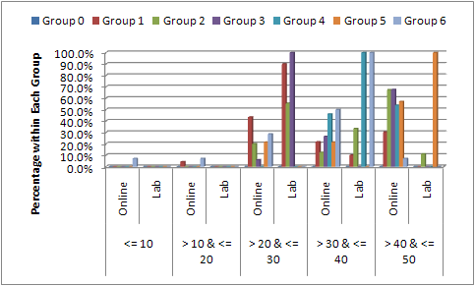
Figure 25: Students’ Distribution Comparison within each Group Per Scored Marks for Quiz
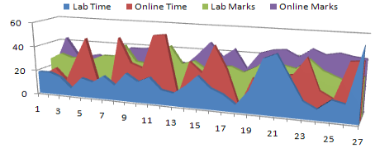  Figure 26: Quiz 1 Defined Intersection Students | 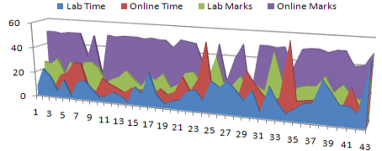  Figure 27: Quiz 2 Defined Intersection Students
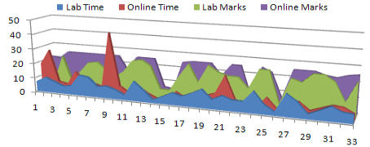  Figure 28: Quiz 3 Defined Intersection Students | 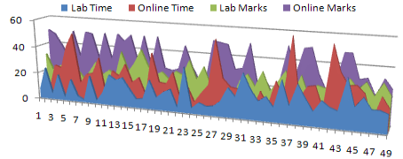  Figure 29: Quiz 4 Defined Intersection Students
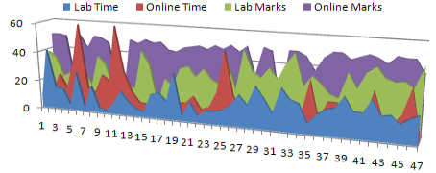  Figure 30: Quiz 5 Defined Intersection Students | 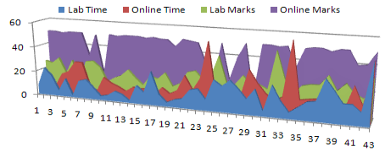  Figure 31: Quiz 6 Defined Intersection Students

- Monitoring Students to Get Closer Look on Cheater’s Tips

To combat cheating, it helps to know how students are pulling it off. Here are some cheating tips that have been witnessed or discovered through monitoring students:
- Access to Answers’ Files: Open the PDF or document file of the assessment, search for keywords, and immediately apply answers. Most students have high memorable capabilities regarding mapping questions and answers.
- Collaborative Solution: Though collaboration is really important in the learning process, the concept of collaborating to cheat was wholly new to me. More than one student conducts the assessment. One holds the laptop, while others hold different pages of material or a long list of assessment answers from all previous exams. Consequently, they optimize their search time. The one holding the laptop reads the question aloud while the others conduct a search for the answers, finding it in no time. Part of the problem here is that in an unsupervised e-learning environment, there is no way to guarantee that students themselves even attended the assessment.

Two categories of students must not be neglected in reviewing this matter:
- Careless students: Some students don’t even read the assessment questions. They pick an answer and they don’t care about the results. There are students who answered 50 questions in less than 3 minutes, which gives them an average reading of 3.6 seconds for each question. Another form of careless was presented in students who did not finish the assessment even though they started it.
- Disengaged students: Almost 23 percent of the enrolled students did not attend any of the e-learning activities. This percentage is huge, and in our course, it is not acceptable at all. Motivating students to attend e-learning classes and activities is always a challenge.

- Proposed Solution
Based on the findings, it is clear that there are issues that shall be considered before providing students with non-supervised online exams. There must be a stronger way of controlling the exam process; in order to make marks more trustworthy. Proposed solutions are to first conduct more studies about the efficiency and effectiveness of assessment, both educational/pedagogical and technological.

  - Pedagogical Solutions
Pedagogical solutions include attempting to present an unlimited assessment items repository, and track students’ progress during the learning process, so peaks can be determined, and they might be a mark for inappropriate activity during the learning process. Also, a timed question is almost a must in the exam process. Timer shall not only start after the student sees the question; we are thinking about calculating time for both displaying and solving the question, so theoretically, students will never find the time to cheat. This paper proposes some tips that can be used as solutions that focuses on four aspects of the online assessment process and can be thought of as the integration of the four of them:

  - Questions-based solution: Assessments banks should consist of a larger number of questions with the chance to have a quarter or third of the assessment different for each student. Also, instructors shall work on updating assessments’ banks and keeping it out of the students’ reach.
  - Environment-based solution: This solution is complementary to the aforementioned one. Supervised e-learning environments are important and are the only way to guarantee a certain accepted level of learning quality. Students can find the time to search the answer files because they simply have the access to them. Hopefully when students don’t have access to such files, they might learn better.
  - Assessment-based solution: This solution would use a timer that forces students to read questions before viewing the answers. Maybe by forcing student to wait for answers before s/he can choose one of them will be a catalyst for the student to read the question thoroughly and consider all the answers.
  - Student-based solution: Talking to students about the importance and benefits of e-learning activities is important. Not all students yet believe in e-learning, and not all of them cared about attending the online course activities. The rest needs to be told explicitly, instead of being neglected.

Nowadays, most students do their best to play it smart, even if they will not follow the rules. Instructors need to think about solutions to guarantee learning efficiency and effectiveness regularly. Unfortunately, students usually adopt and master technology for their purposes (even cheating) very quickly. Instructors need to evaluate regularly and rely more on student performance analysis tools to find facts that are not clear to us.

  - Technical Aspects of the Solution
Technical solutions are a real challenge. There is no web-based assessment system that provides a perfect solution. Rather, solutions lie in a well-controlled desktop application that must be used in the exam. Desktop applications that are not available via Web-based systems include:
- Keyboard hooking: Desktop application can control keyboard strikes on a system basis; not on an application basis. We can control which keys are available for students to click, and which are not. However, such a solution is applicable for Microsoft Windows-based desktop applications only; because Java Virtual Machine (JVM) doesn’t provide such control over operating system, and that will stop authors from developing a platform independent exam desktop application.
- Operating system log file: Desktop application can check the operating system log file, and when it finds that student executed any of the non-authored applications during the exam, it exits the exam. However, students can be smart enough to use two computers: one for taking the exam and another for looking up answers. Besides, checking the log file will be a time-based process that is not guaranteed to take place anytime.
- Check running processes: Desktop application will check the running processes on the system before and during the exam, and will exit any non-exam required process that is running during the exam. This technique seems to be the most appropriate one; however building this list of processes will take time and effort.

By combining the aforementioned techniques; both educational and technical, we might get a better circumstances during exams.

- Conclusion

In the move towards relying on e-Learning activities, it is important to get closer to students’ behavior. Our situation puts lot of challenges in our way of implementing supervised online assessment environment. One of the proposed solutions was the utilization of non-supervised e-Learning environments. When that environment took place in the academic years 2007-08, and 2008-09 there was a problem with category of students who don't spend enough time reading the questions, and they get average marks around 20 out of 50. Cheating instances was suspended and thus the study presented in this paper started taking place. This study research questions are mainly focusing on the relation between Time and Scored Marks? Is it proportional? What is the truthfulness of the thought that the more time the student spends solving the assessment, the higher marks s/he gets?
In order to answer those questions, Additional six online assessments took place in the academic year 2009-10 and after further analyzing and mining assessments' data and results, it is clear that instructors and assessments need to address two categories of problems that cause problems:
- Students who actually don't read the questions and try their choices in the exams by selecting what makes sense to them. Those students can be easily entrapped via “Hard Questions” as it has noticed from analyzing group's responses to hard questions. Tricky questions can serve also in filtering this category.
- Students who take too much long time solving the quizzes. Instructors shall not leave long times, because based on our findings it is clear that students who cheats usually spend much time solving the quiz.
- From noticing Group C Intersection Students, it's clear that students take the cheating chance when they can. So, there are important need to utilize supervised e-Learning environments, and present pedagogical and technological solutions to fight cheating, as highlighted in the proposed solution.
Analyzing assessments’ data and results yields the fact that there is an optimal time for solving the assessment, and that should be the time given to student to answer the assessment; no more and no less. If this time is not adequately detected, there are high opportunities for cheating to take place. Also, there is a minimum needed time; at least time needed for reading the questions. Students who solve the assessments in almost no time shall not miss marks; however, LMS shall record this behavior so instructors can check their cases separately. It's useful not to tell students that LMSs have the ability to track students' habits in the assessments. There must be a very well defined balance between questions, marks, and time as the main assessments’ components. This balance is controlled and maintained by instructor. Further and advances statistical analysis tools and data mining techniques are important and required to further understand students’ behavior in assessments, and generally e-Learning.
References
Alfred Rovai. (2000). “Online and traditional assessments: What is the difference?” Internet and Higher Education, Elsevier.
Caroline Gipps (1994). “Beyond Testing”. Routledge.
C. Romero, S. Ventura. (2007). “Educational data mining: A survey from 1995 to 2005”.Expert Systems with Applications, Vol. 33, Issue 1, Elsevier.
C. Romero, S. Ventura. (2006). “Data Mining in e-Learning”. WIT Press, Southampton, Boston.
Cristo bal Romero , Sebastian Ventura, Enrique Garcia. (2007). “Data Mining in Course Management Systems: Moodle case study and tutorial”. Computers and Education, Elsevier.
Haitham A. El-Ghareeb (2009). “E-Learning and Management Information Systems: Universities Need Both”, eLearn Magazine, ACM”
Khaled Hammouda, Mohamed Kamel. (2006). “Data Mining in e-Learning”. Edited Book: Samuel Pierre. “E-Learning Networked Environments and Architectures: A Knowledge Processing Perspective (Advanced Information and Knowledge Processing)”. Springer
SQL Server 2008 Books Online. (2009). “Data Mining Algorithms (Analysis Services - Data Mining)”. Microsoft Development Network. Retrieved on 16th June 2010 from http://msdn.microsoft.com/en-us/library/ms175595(v=SQL.100).aspx
SQL Server 2008 Books Online. (2009). “Microsoft Clustering Algorithm”. Microsoft Development Network. Retrieved on 16th June 2010 from http://msdn.microsoft.com/en-us/library/ms174879(v=SQL.100).aspx
Jane Seale, Using CAA to support student learning, LTSN Generic Center

Brawner, C.E., Practical Tips for Using Web-based Assessment Systems, T.H.E. Journal, 28(4), 38-39, 2000.

Camille F. Rogers (2006) Faculty Perceptions about e-Cheating during Online Testing, In Proceedings of Consortium for Computing Sciences in Colleges (CCSC) Southeastern
Conference

Eugene Burke, “Better Practice for Unsupervised Online Assessment”, SHL White Paper, 2006

Kirillova, Bulletin of of The American Society for Information Science, Vol. 26, No. 4, April/May 2000

Baker, R., Papp, R., Academic Integrity Violation in the Digital Realm,
Proceedings from the Southern Association for Information Systems 2003 Annual
Conference, 193-202, 2003.

Young, J., Texas Colleges Collaborate to Offer Online Students Convenient Proctored Tests, Chronicle of Higher Education, 47(26), A43-46, 2001.

Carlson, R., Assessing Your Students: Testing in the Online Course, Syllabus,
12(7), 16-18, 2000.

